3.2 Creation of Views (Question d)

1.

CREATE VIEW available_room (room_number) AS

SELECT r.room_number

FROM room r, check_in ci

WHERE r.room_number != ci.room_number

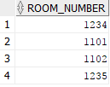

2.

CREATE VIEW popular_event_manager (event_staff_id) AS

select event_manager_id

from event

where TO_CHAR(event_date, 'MMDD') >= TO_CHAR(SYSDATE - 30, 'MMDD')

group by event_manager_id

having count(event_id) > 10

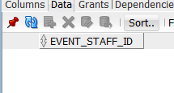

3.

CREATE VIEW frequent_customer (customerID) AS

SELECT i.customerID

FROM individual i, check_in ci

WHERE trunc(ci.Check_in_date, 'YEAR') = trunc(sysdate,'YEAR') and i.customerID = ci.customerID

GROUP BY i.customerID

having COUNT(ci.Check_in_date) >= 10

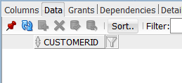

4.

CREATE VIEW popular_room (room_number) AS

SELECT r.room_number

FROM check_in ci, room r

WHERE r.room_number = ci.room_number and trunc(ci.check_in_date, 'YEAR') > trunc(sysdate,'YEAR')

GROUP BY r.room_number

having count (ci.check_in_date) > 30

